**Java Programming**- **Practical File**

**Paper Name: P-VII Java Lab**

**Paper Code: BCA - 252**

***Submitted by - Submitted to -***

**Ayush Pun Dr. Kavita Pabreja**

**02314902020 (Associate Professor)**

***in partial fulfillment for the award of the degree***

***of***

**BACHELOR OF COMPUTER APPLICATION**



**MAHARAJA SURAJMAL INSTITUTE**

**C-4, JANAK PURI,**

**NEW DELHI - 110058**

MAY 2022

**Index**

|  |  |  |  |
| --- | --- | --- | --- |
| **S.No.** | **Program statement** | **Date of execution** | **Teacher’s Signature** |
|  | Calculate and print: 1+ ½ + 1/3 + ¼+…+ 1/n. Take n as input from user. |  |  |
|  | Demonstrate the effect of nested break. |  |  |
|  | Demonstrate the use of Scanner class to input a number and print its table. Print its factorial also |  |  |
|  | Create a 3 x 3 array. Input all elements and display all. Use functions for input and display. |  |  |
|  | WAP to find volume of sphere, cone and cylinder using method overloading. Take input from user using scanner class. |  |  |
|  | Demonstrate the concept of static variable, static function and static block. |  |  |
|  | Demonstrate the concept of super to access base class data member and method. |  |  |
|  | Demonstrate the concept of multilevel inheritance. Use parameterized constructors and use super to construct object of superclasses. |  |  |
|  | WAP to demonstrate run-time polymorphism/dynamic method dispatch. |  |  |
|  | Demonstrate the concept of aggregation/nested class. |  |  |
|  | Demonstrate the concept of interface for vehicle. |  |  |
|  | Demonstrate the concept of constructors in abstract class. |  |  |
|  | Demonstrate the scenario of multiple inheritance using multiple interfaces. |  |  |
|  | Demonstrate the concept of extending interfaces. |  |  |
|  | WAP to demonstrate Checked or Unchecked exception. |  |  |
|  | WAP to input salary of a person along with his name, if the salary is less than 70,000 then throw an arithmetic exception with a proper message “not eligible for loan”. |  |  |
|  | Spawn 3 child threads. Make use of sleep() method. Let each of the three threads and main thread print appropriate message. |  |  |
|  | Display ID’s of 5 different child threads spawned from main. |  |  |
|  | Demonstrate application of isAlive() or join() method. |  |  |
|  | Spawn 3 child threads with different priorities. Display their names and priorities. |  |  |
|  | Demonstrate the use of synchronization by spawning 3 different threads. |  |  |
|  | Demonstrate inter-thread communication. |  |  |
|  | Take input from keyboard and write into a file using character stream and byte stream. |  |  |
|  | Copy an existing text file into a newly created text file using both types of stream. |  |  |
|  | Write an applet to Display a moving banner. |  |  |
|  | Write an applet that shows the following AWT controls  -> checkbox  -> choice list  -> push button |  |  |
|  | WAP to accept details of employee(name , eno ,mobile no, designation, salary) using AWT controls. |  |  |
|  | Write an applet that implements MouseListener and MouseMotionListener. |  |  |
|  | WAP that accepts 10 names from keyboard and arrange them in dictionary order. |  |  |
|  | Write an applet / swing that demonstrates working of 3 scrollbars (RGB) to change background color. |  |  |
|  | Write a program to implement any one of the 4 layout managers. |  |  |
|  | WAP to connect to any database using JDBC Type 4 driver. |  |  |
|  | WAP to demonstrate use of TCP and UDP methods. |  |  |

1. Calculate and print: 1+ ½ + 1/3 + ¼+…+ 1/n. Take n as input from user.

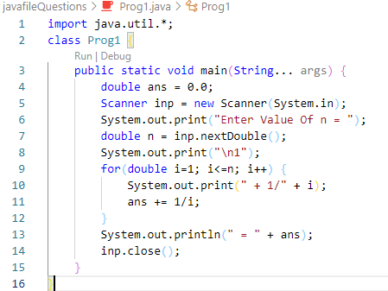

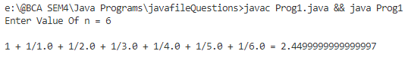Output:

1. Demonstrate the effect of nested break.

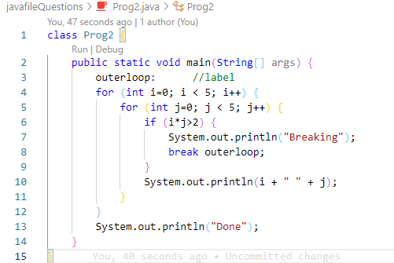

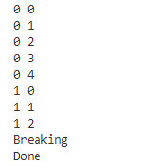Output:

1. Demonstrate the use of Scanner class to input a number and print its table. Print its factorial also

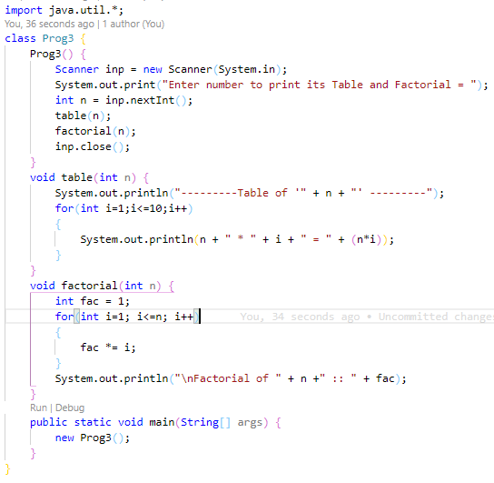

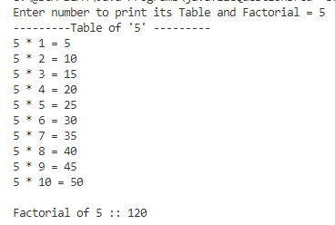Output:

1. Create a 3 x 3 array. Input all elements and display all. Use functions for input and display.

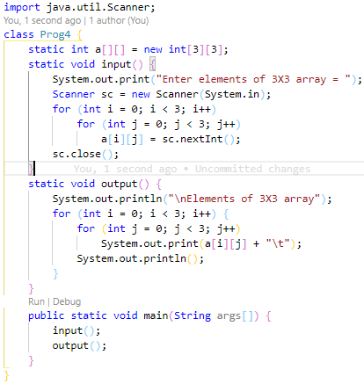

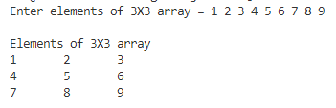Output:

1. WAP to find volume of sphere, cone and cylinder using method overloading. Take input from user using scanner class.

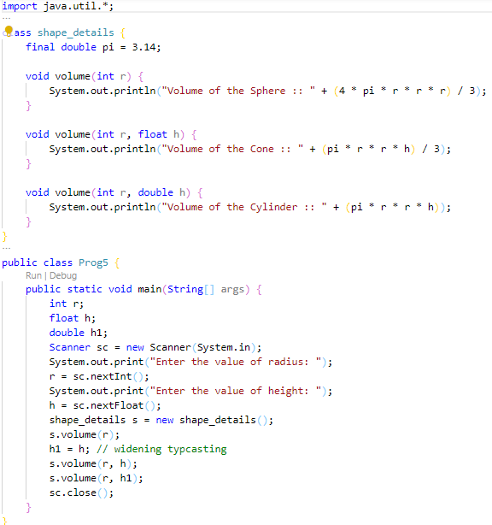

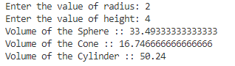Output:

1. 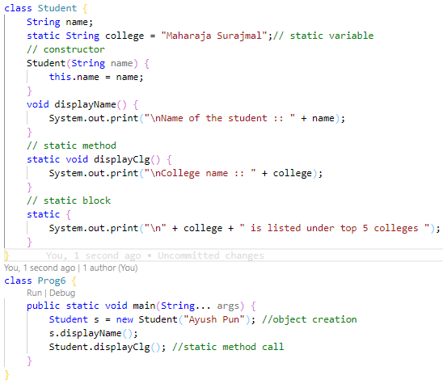Demonstrate the concept of static variable, static function and static block.

Output:

1. Demonstrate the concept of super to access base class data member and method.

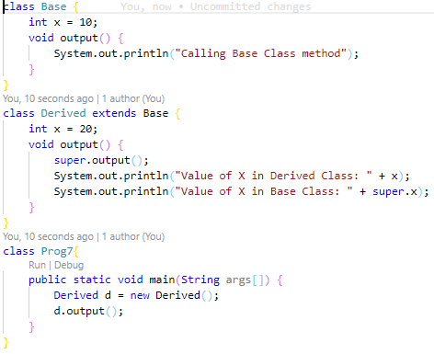

Output:

1. Demonstrate the concept of multilevel inheritance. Use parameterized constructors and use super to construct object of superclasses.

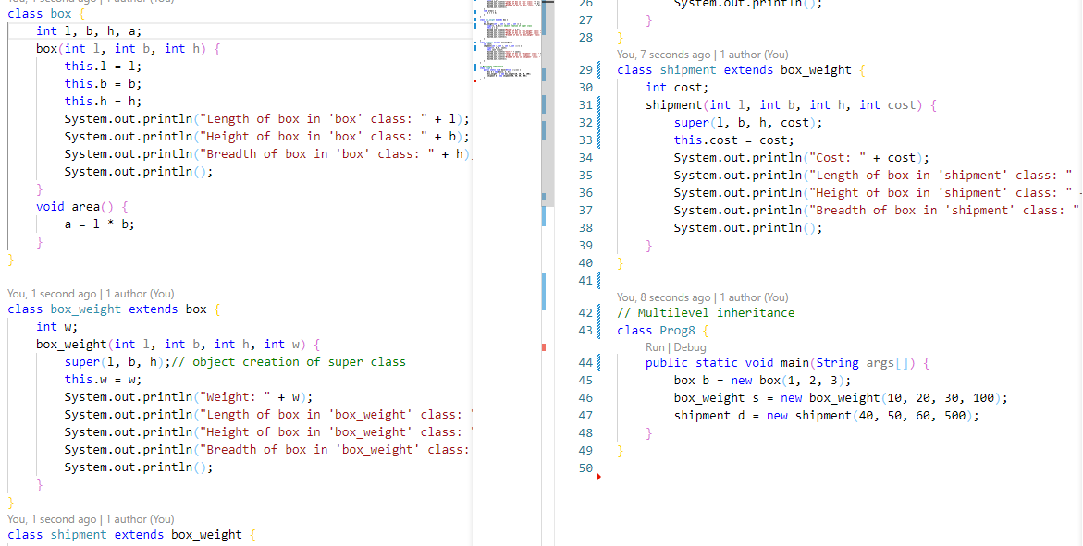

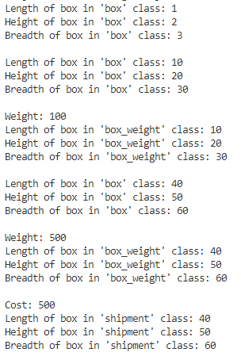Output:

1. WAP to demonstrate run-time polymorphism/dynamic method dispatch.

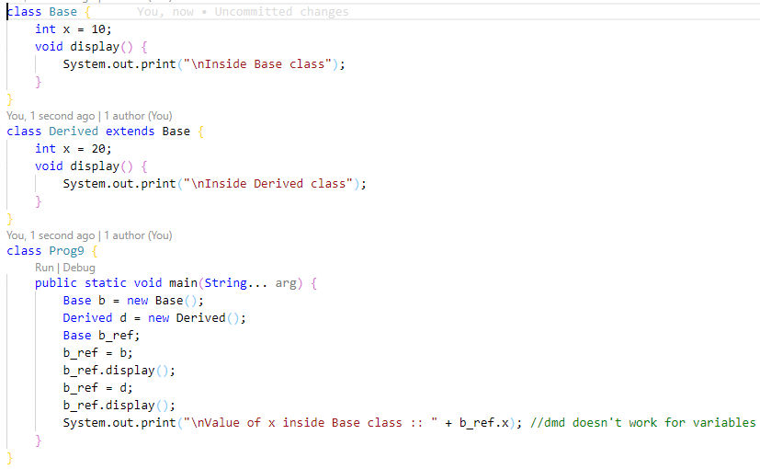

Output:

1. Demonstrate the concept of aggregation/nested class.

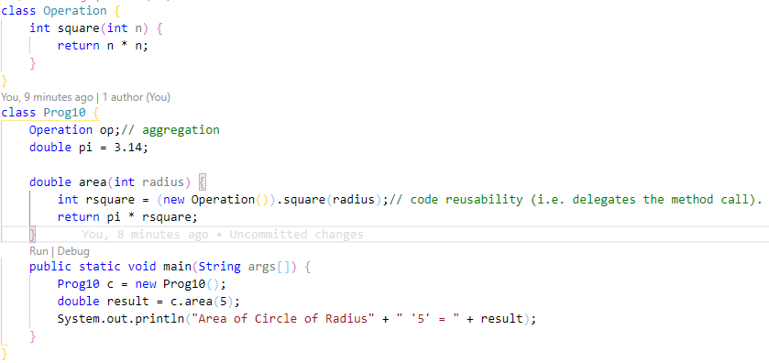

Output:

1. Demonstrate the concept of interface for vehicle.

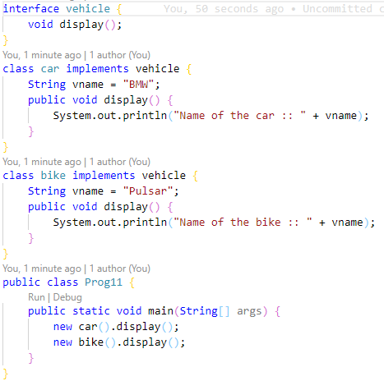

Output:

1. Demonstrate the concept of constructors in abstract class.

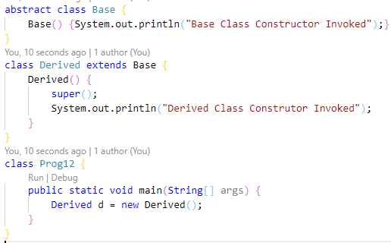

Output:

1. Demonstrate the scenario of multiple inheritance using multiple interfaces.

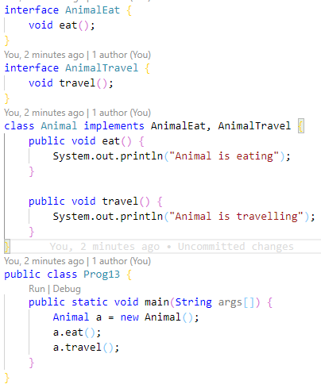

Output:

1. Demonstrate the concept of extending interfaces.

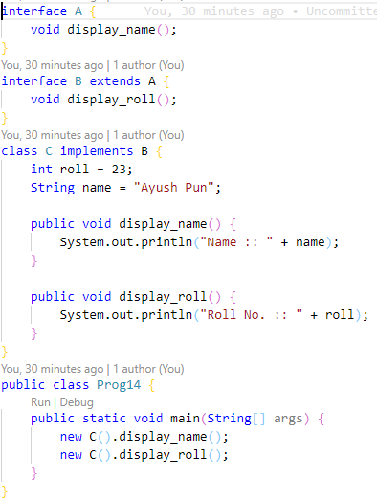

Output:

1. WAP to demonstrate Checked or Unchecked exception.

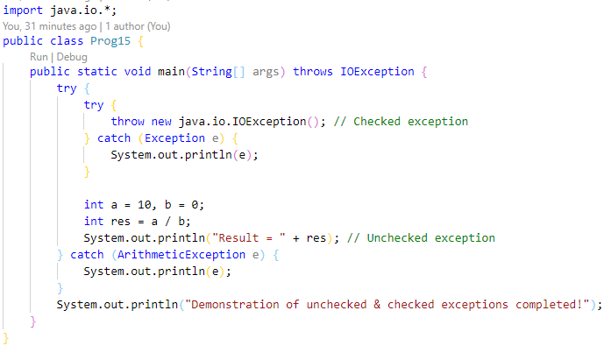

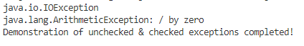Ourput:

1. WAP to input salary of a person alongwith his name, if the salary is less than 70,000 then throw an arithmetic exception with a proper message “not eligible for loan”.

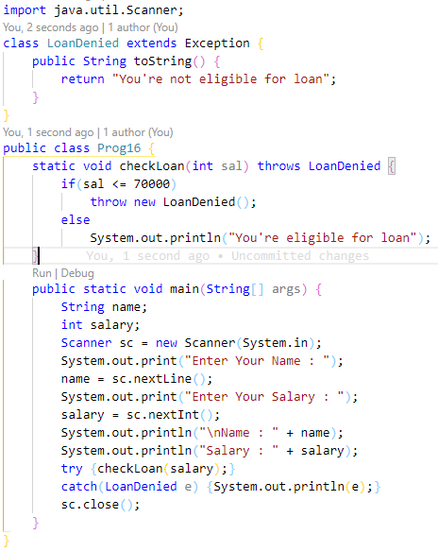

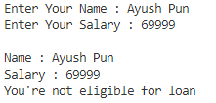Output:

1. Spawn 3 child threads. Make use of sleep() method. Let each of the three threads and main thread print appropriate message.

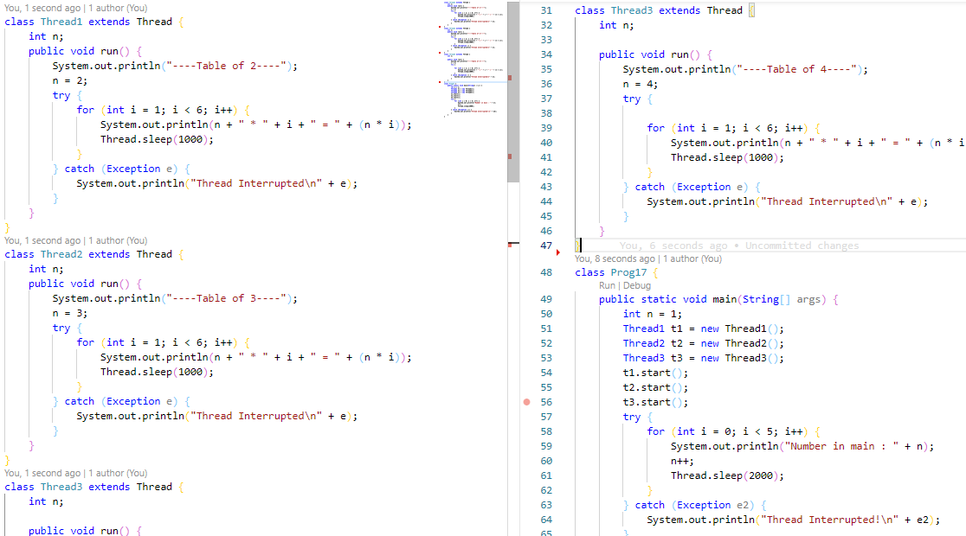

Output:

1. Display ID’s of 5 different child threads spawned from main.

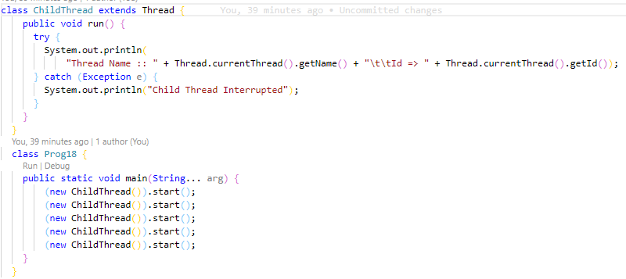

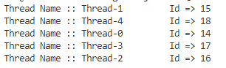Output:

1. Demonstrate application of isAlive() or join() method.

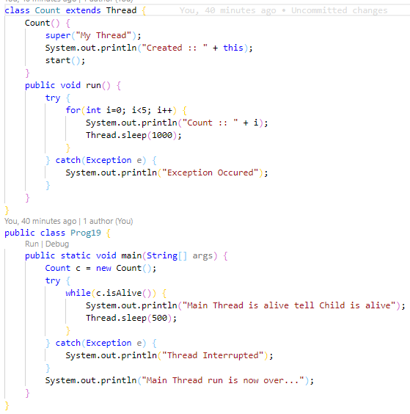

Output:

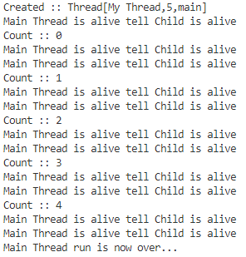

1. Spawn 3 child threads with different priorities. Display their names and priorities.

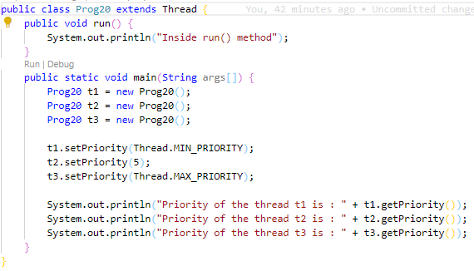

Output:

1. Demonstrate the use of synchronization by spawning 3 different threads.

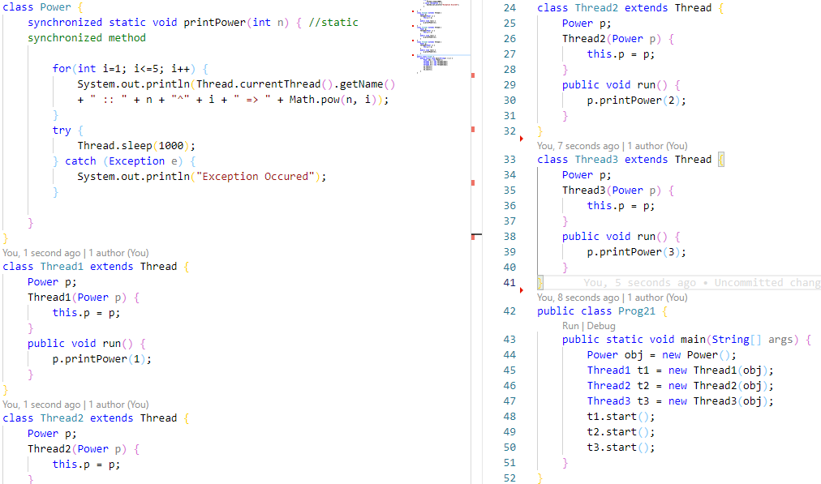

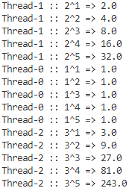Output:

1. Demonstrate inter-thread communication.

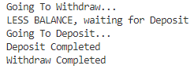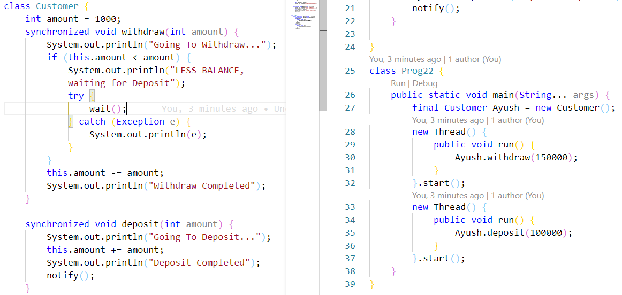

Output:

1. Take input from keyboard and write into a file using character stream and byte stream.

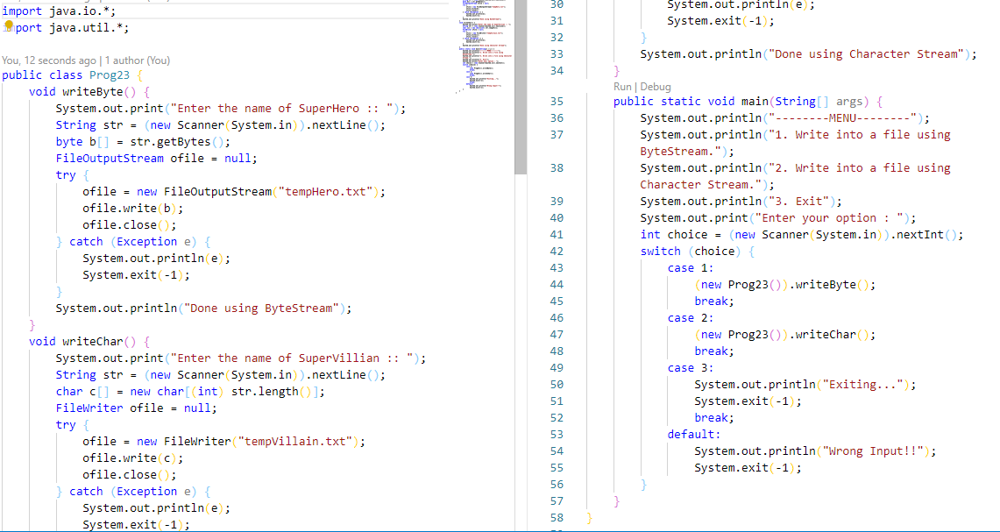

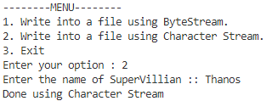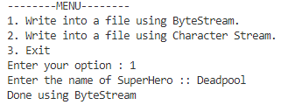Output:

1. Copy an existing text file into a newly created text file using both types of stream.

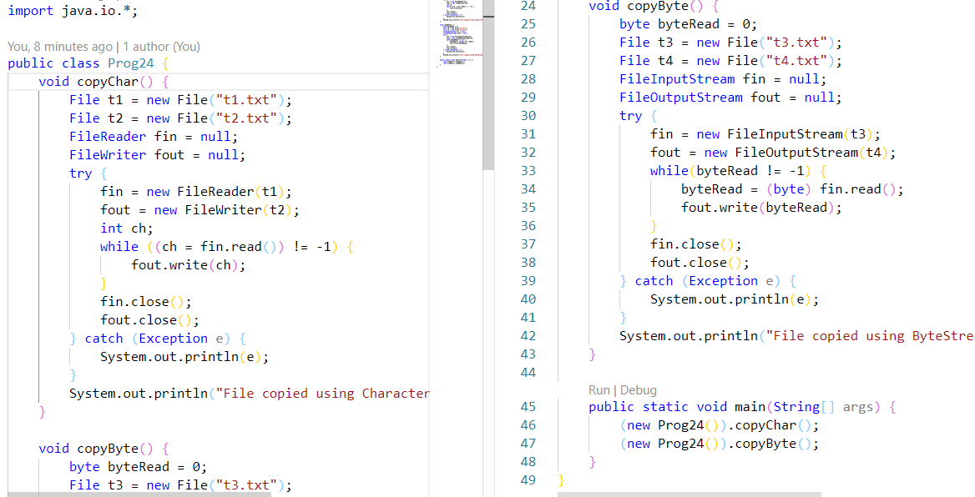

Output:

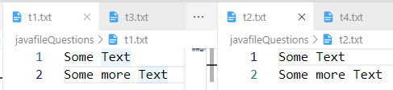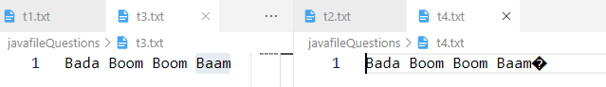

1. Write an applet to Display a moving banner.

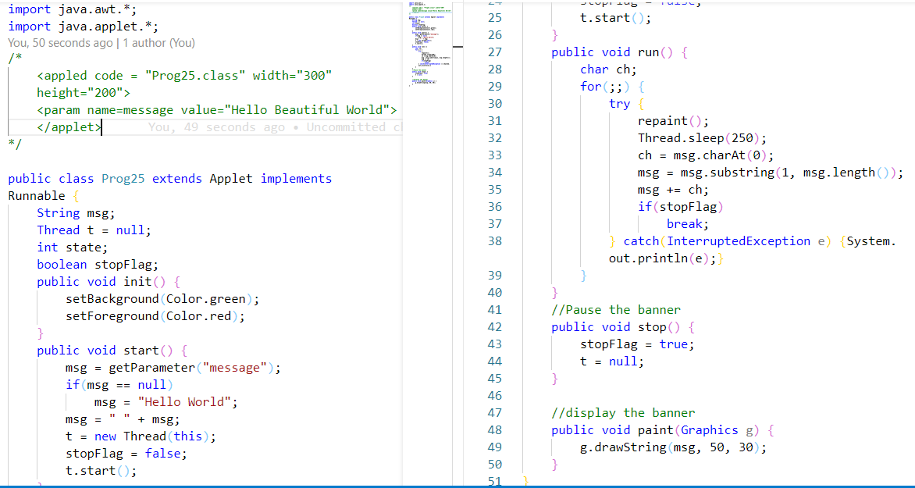

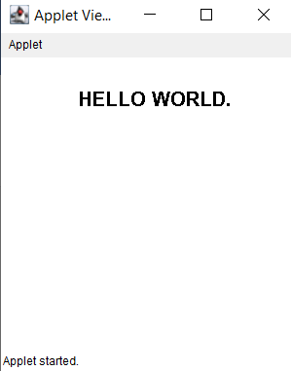Output:

1. Write an applet that shows the following AWT controls  
    -> checkbox  
    -> choice list  
    -> push button

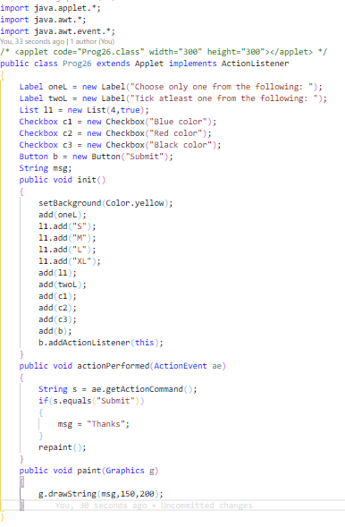

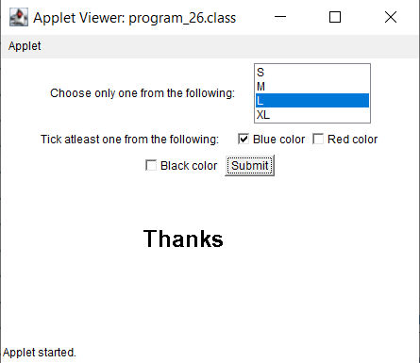Output:

1. WAP to accept details of employee(name , eno ,mobile no, designation, salary) using AWT controls.

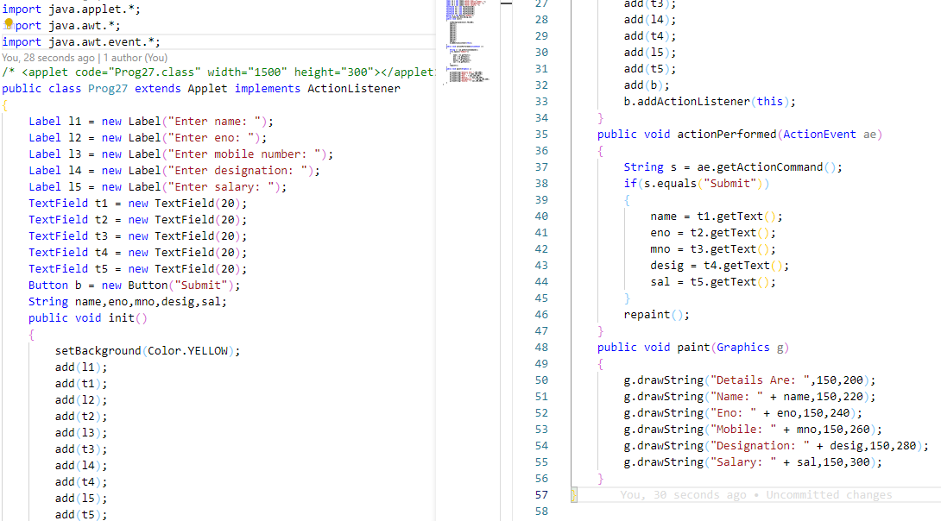

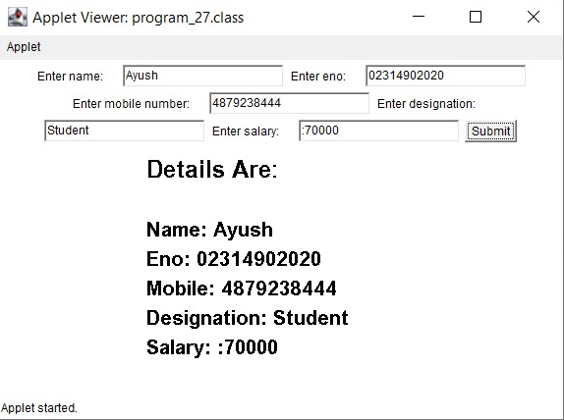Output:

1. 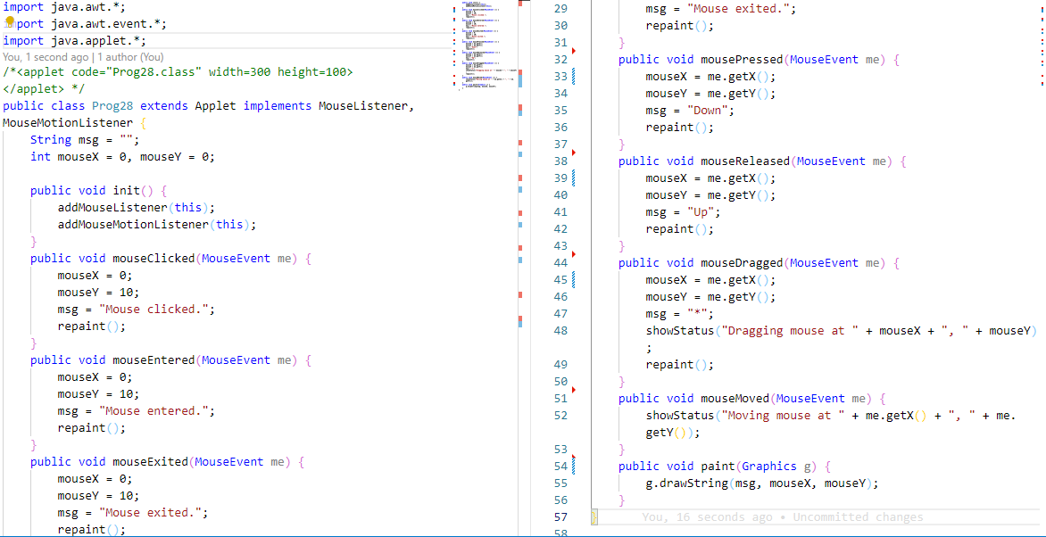Write an applet that implements MouseListener and MouseMotionListener.

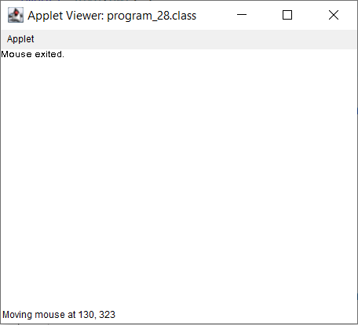Output:

1. WAP that accepts 10 names from keyboard and arrange them in dictionary order.

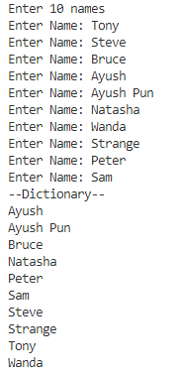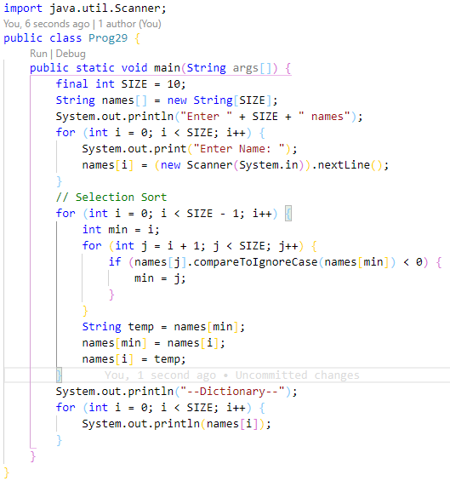

Output:

1. Write an applet / swing that demonstrates working of 3 scrollbars (RGB) to change background color.

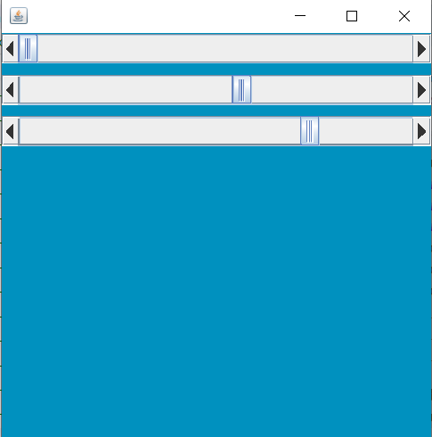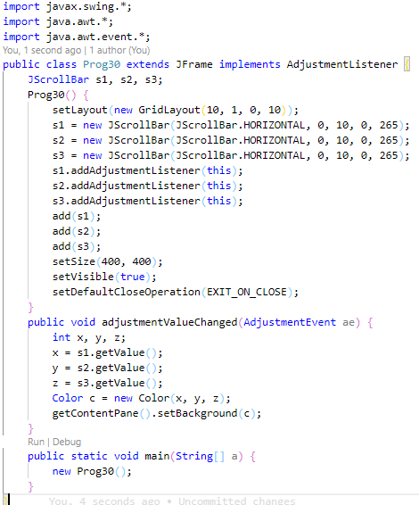

Output:

1. Write a program to implement any one of the 4 layout managers.

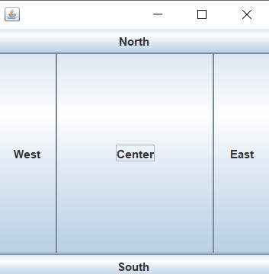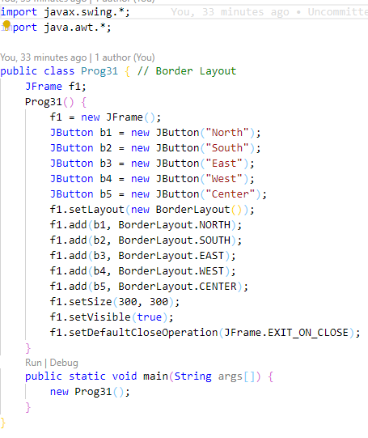

Output:

32. WAP to connect to any database using JDBC Type 4 driver.

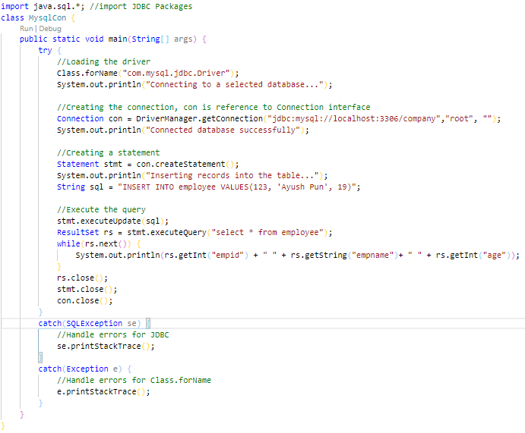

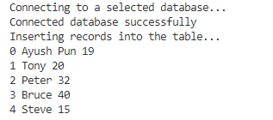

Output:

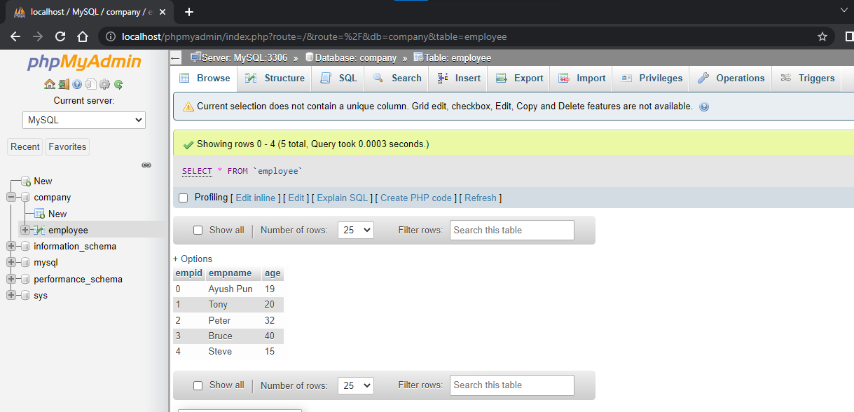

1. WAP to demonstrate use of TCP and UDP methods.

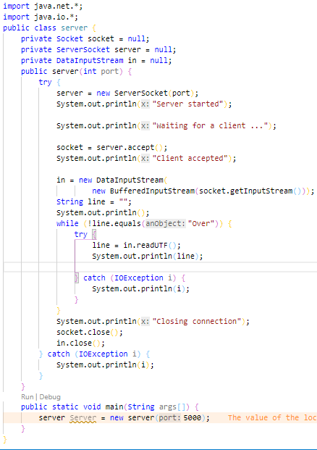Server Side :



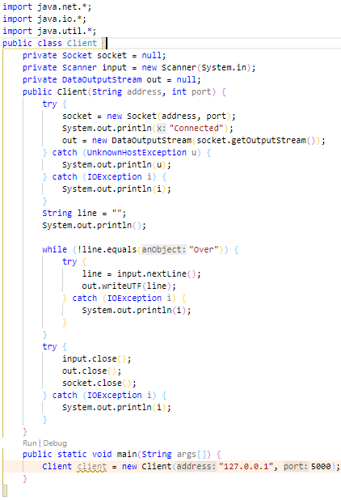Client Side: